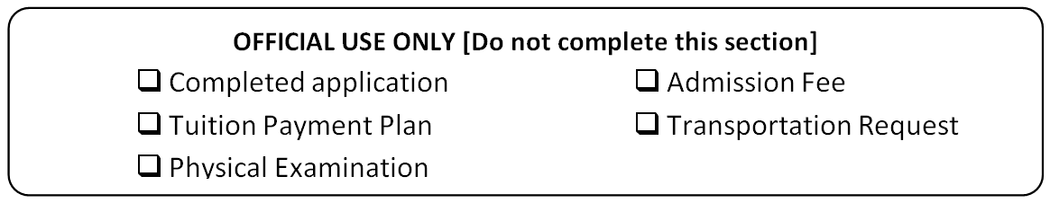
APPLICATION FOR ADMISSION
2017 – 2018
Applicant’s Name (last , first)  <<Applicant's Last Name>>, <<Applicant's First Name>> |  |  |  | Grade to be entered:  <<What grade will the child be entering?>>
Street  <<Street>> | City  <<City>> |  | Zip  <<Zip code>> | Father’s Name  <<Father's Name>>
Home Phone  <<Phone number>> |  | Emergency Phone  <<Addtional phone number>> |  | Mother’s Name  <<Mother's Name>>
Place of Birth  <<Place of Birth>> |  | Date of Birth  <<Date of Birth>> |  | School District  <<In which school district do you reside?>>

List all previous schools in chronological order.
School | Address | Grades | Years attended | Principal
<<Name of school>> | <<School Address>> | <<Grade(s) in school>> | <<Years Attended>> | <<School Principal>>
<<Name of school 2>> | <<School 2 Address>> | <<School 2 Grade(s)>> | <<Years Attended School 2>> | <<School 2 Principal>>

Has your child repeated a grade? | <<Has the child repeated a grade?>>
If “yes”, which grade? | <<Which grade did the child repeat?>>
Will your child ride the bus? | <<Will the child ride the bus?>>

Siblings (oldest – youngest)
Name | DOB | Name | DOB
<<Sibling 1>> | <<Date of Birth Sibling 1>> | <<Sibling 5>> | <<Date of Birth Sibling 5>>
<<Sibling 2>> | <<Date of Birth Sibling 2>> | <<Sibling 6>> | <<Date of Birth Sibling 6>>
<<Sibling 3>> | <<Date of Birth Sibling 3>> | <<Sibling 7>> | <<Date of Birth Sibling 7>>
<<Sibling 4>> | <<Date of Birth Sibling 4>> | <<Sibling 8>> | <<Date of Birth Sibling 8>>

Church the child attends:  <<Church the child attends>> | Pastor’s Name  <<Pastor's name>>

Parent Code of Conduct
(Guardians assume the same responsibility as parents)

- We understand the policies and standards of the school and pledge our support of the school and its administration.

- The school has full discretion in the discipline of my child.

- The school has full discretion for placing my child in the proper level, regardless of the grade completed prior to transfer to this school.

- My participation is needed in lending practical help and prayer support in a mutual effort to train our children.

- We will fulfill all financial obligations in a timely manner.

- We understand that if for any reason our child will be withdrawn from the school, we will submit a notice of withdrawal one month prior. Failure to do so will result in a penalty fee.

- The school reserves the right to suspend or dismiss any student who does not cooperate with the educational process.

<<By writing my name, I understand and agree to the condition stated above. (Father)>> |  | <<Date>>
Father’s Signature |  | Date
<<By writing my name, I understand and agree to the condition stated above. (Mother)>> |  | <<Date>>
Mother’s Signature |  | Date

For Official Use Only

